Integrated Science– General Year 12 2017

## Task 7 – Unit 4

**Assessment Type:** Test

**Task Weighting :** 10% **Name :**

Physical and chemical properties and mixtures test

Important Information for Students

1. There are THREE sections in this test - Multiple Choice, Short Answer and Extended Answer.
2. This is a closed-book assessment (no notes are allowed)
3. The time allowed to complete the test is 55 minutes.
4. Circle the correct answer of each question in the Multiple Choice section
5. Write your answers to the Short Answer section in space provided.

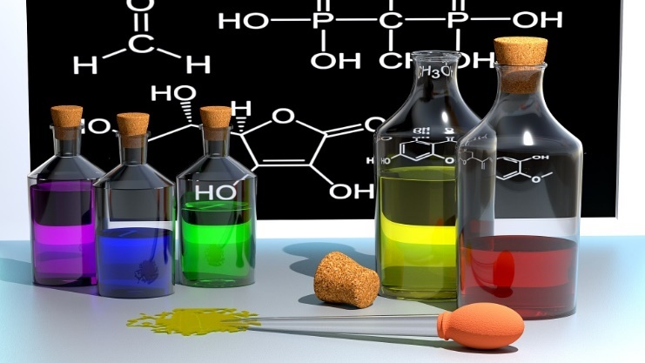

|  |  |
| --- | --- |
| Multiple Choice | /10 |
| Short Answer | /37 |
| Total | /47 |

**Multiple Choice Section:** 10 Questions (10 Marks)

Put a circle around the letter (a, b, c or d) that is the best answer to the question.

1. Which of the following is an example of physical change?
2. Mixing baking soda and vinegar together, and this causes bubbles and foam.
3. A glass cup falls from the counter and shatters on the ground.
4. Lighting a piece of paper on fire and the paper burns up and leaves ashes.
5. Baking a birthday cake for your mother.
6. Which of the following is an example of chemical change?
7. Filling up a balloon with hot air.
8. Taking a glass of water and freezing it by placing it in the freezer.
9. A plant collecting sunlight and turning it into food.
10. Your dog ripping up your homework.
11. Which change can be easily be reversed?
12. Chemical Change
13. Physical Change
14. Both a physical and chemical change
15. Neither a physical or chemical change
16. When a new substance is formed with different properties than the original substance it is called a
17. Chemical change
18. Physical change
19. Freezing
20. Boiling
21. Which of the following would not be a suitable method for separating an insoluble solid and liquid?
22. Decanting
23. Evaporation
24. Filtration
25. Chromatography
26. Which of the following substances is a mixture?
27. Salt
28. Sea water
29. Copper
30. Distilled water
31. Which of the following cannot be dissolved in water?
32. Salt
33. Sugar
34. Copper sulphate
35. Sand
36. Which one of the following methods is used to separate the colours in food dyes?
37. Chromatography
38. Filtration
39. Sieving
40. Decanting
41. Which of the following is not a separation technique?
42. Fishing net
43. Tea strainer
44. Boiling an egg
45. Surgical mask
46. Distillation is used to:
47. separate one substance dissolved in another
48. separate different dyes in pens
49. separate two liquids with different boiling points
50. separate solids of different sizes

Short Answer Section: 10 Questions (37 Marks)

*Answer the questions in the spaces provided*

1. State 3 ways in which you could tell that a chemical reaction has taken place. **(3 Marks)**

________________________________________________________________________________________________________________________________________________________________________________________________________________________________________________________________________________________________________________________________________________________________________________________________________________________________________________________________________________________________________________________

1. Distinguish between: **(4 Marks)**
2. Exothermic and endothermic

____________________________________________________________________________________________________________________________________________________________________________________________________________________________________________________________________________________________________________________________________

1. Physical and chemical change

____________________________________________________________________________________________________________________________________________________________________________________________________________________________________________________________________________________________________________________________________

1. Soluble and insoluble

____________________________________________________________________________________________________________________________________________________________________________________________________________________________________________________________________________________________________________________________________

1. Saturated and supersaturated

____________________________________________________________________________________________________________________________________________________________________________________________________________________________________________________________________________________________________________________________________

1. 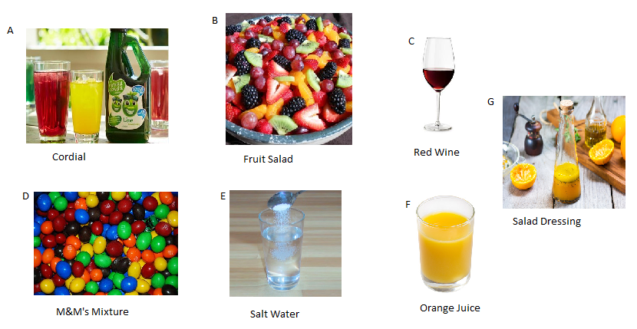The following are examples of mixtures use the diagram to answer the questions below
2. Which of the following are homogenous mixtures? **(1 Mark)**

__________________________________________________________________________________

1. Which of the following are heterogenous mixtures? **(1 Mark)**

__________________________________________________________________________________

1. Which of these mixtures is a solution? **(1 Mark)**

___________________________________________________________________________________

1. Four substances called A, B, C and D were shaken with water. This is what happened

**(4 Marks)**

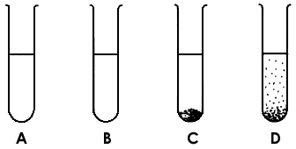

The substances were then shaken with alcohol. This is what happened.

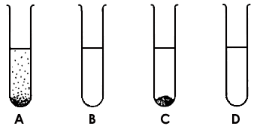

Complete this table.

|  |  |  |
| --- | --- | --- |
| Substance | Is it soluble in water? | Is it soluble in alcohol? |
| A |  |  |
| B |  |  |
| C |  |  |
| D |  |  |

1. 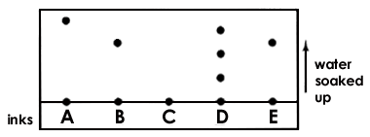The diagram shows the results of a chromatography experiment. Fine inks were compared: A, B, C, D and E. **(3 Marks)**
2. Which ink is a mixture of different colours?

_________________________________________________________________________________

1. Which two inks are the same?

_________________________________________________________________________________

1. Which ink is not soluble in the solvent?

_________________________________________________________________________________

1. You have been presented with a mixture of sand, salt, iron, rocks and poppy seeds. Explain in detail, how you would separate each substance and the order in which you would separate the mixture.

**(5 Marks)**

_______________________________________________________________________________________________________________________________________________________________________________________________________________________________________________________________________________________________________________________________________________________________________________________________________________________________________________________________________________________________________________________________________________________________________________________________________________________________________________________________________________________________________________________________________________________________________________________________________________________________________________________________________________________________________________________________________________________________________________________________________________________________________________________________________________________________________________________________________________________________________________________________________________________________________________________________

1. State at least two methods of separation that can be used to separate a: **(3 Marks)**
2. a solid from another solid

_______________________________________________________________________________

1. a solid from a liquid

_______________________________________________________________________________

1. a liquid from another liquid.

_______________________________________________________________________________

1. Some washing machines do some test spins before starting the spin-dry cycle. After doing this, the machine may not spin the clothes but instead agitate them back and forth for a while, before trying another test spin. **Propose** a reason why the machine has been designed to do this. **(2 Marks)**

______________________________________________________________________________________________________________________________________________________________________________________________________________________________________________________________________________________________________________________________________________________________________________________________________________________________________________________________________________________________________

1. A reaction took place between sulfuric acid and magnesium to produce magnesium sulfate and a gas state the gas produced and write a word equation to represent this information. **(2 Marks)**
2. A reaction between hydrochloric acid and sodium hydroxide occurred to produce sodium chloride and another substance. State the other substance and write a formula equation to represent this information. **(2 Marks)**
3. If you are lost in the bush and have no drinking water, you can make a ‘bush still’ to try to collect some.
4. Comparethe ‘bush still’ shown below with a distillation apparatus. **(3 Marks)**

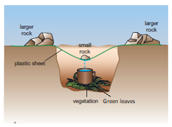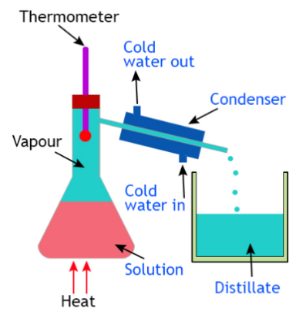

_______________________________________________________________________________________________________________________________________________________________________________________________________________________________________________________________________________________________________________________________________________________________________________________________________________________________________________________________________________________________________________________________________________________________________________________

1. Explainhow it can be considered an example of distillation. **(3 Marks)**

________________________________________________________________________________________________________________________________________________________________________________________________________________________________________________________________________________________________________________________________________________________________________________________________________________________________________________________________________________________________________________________________________________________________________________________________________________________________________________________________________